

CSE541 Computer Vision

Weekly Report

Section-1

Group 1 - Fantastic Four

Submitted to faculty: Prof. Mehul Raval

Date of Submission: 23 March 2022

Student Details

| Roll No. | Name of the Student | Name of the Program |
| --- | --- | --- |
| AU1940315 | Shubham Jain | BTech-CSE |
| AU1940169 | Gaurav Bajaj | BTech-CSE |
| AU1940215 | Raj Chauhan | BTech-CSE |
| AU1940118 | Raj Gariwala | BTech-CSE |

**Tasks Performed in the week:**

* This week all the tasks performed were based on and for the mid-semester project presentation.
* We trained the MobileNet model using the concept of transfer learning with pre-trained weights of ImageNet.
* We prepared a dataset for training having a 4:1 ratio of training and testing respectively. To avoid overfitting we used data augmentation.
* We then fitted the data in the model for 50 epochs.

**The outcome of the tasks performed:**

* After training and fitting the data on kaggle using MobileNet model we got following results,

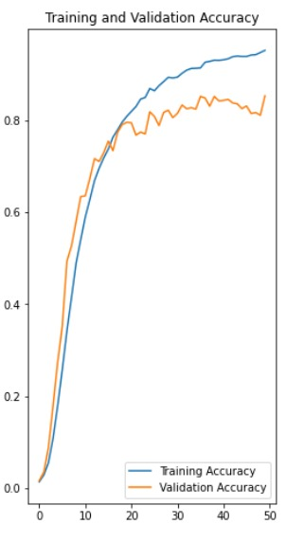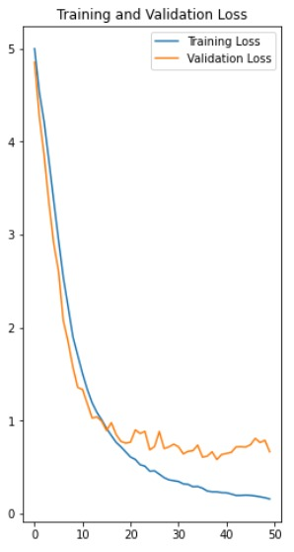

Fig-6. Accuracy vs Epoch Fig-7. Loss vs Epoch

**Tasks to be performed in the upcoming week:**

* As you can see from the output that the data is still overfitted so will need to solve that.
* Work on valuable suggestions given during the presentation.
* Train model using triplet loss function.
* We are also planning to work on several challenges during Real time face recogntion as was suggested during the presentation.